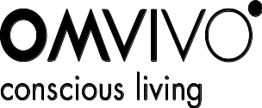

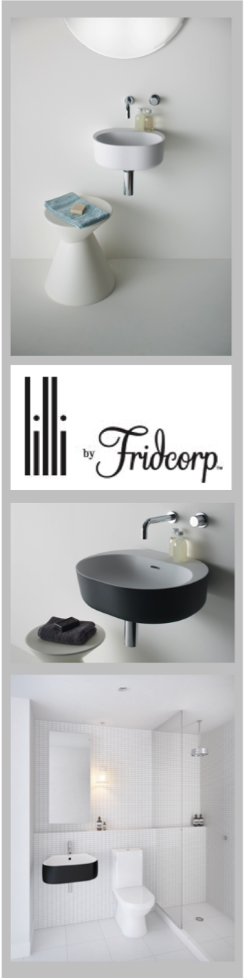
Lilli Custom Design September 2011
Lilli is the latest custom designed basin from Omvivo, originally created for the prestigious Fridcorp Lilli Apartments in South Yarra. The basin perfectly compliments Lilli apartments contemporary interior design by Australian visionary design teams, architects Elenberg Fraser and interior designers Hecker Guthrie.
The Italian made basin is available in white solid surface and Softskin colour options. Lilli is a wall-mounted basin that can also be installed onto a bench top and be supplied with or without a tap hole. It is available in two sizes; 400 and 550.

“When creating the Lilli basin, I wanted to showcase the versatility of two distinct materials; Softskin and solid surface. When using solid surface it is possible to create thinner, stronger wall thicknesses than ceramic, giving the basin a lighter appeal. The Softskin finish gave the basin a two tone affect which allowed the design to effectively relate to Hecker Guthrie’s interior scheme”.
-Thomas Coward, Principal Designer, Omvivo

Omvivo worked closely with the Lilli Apartment’s interior designers and the developer Fridcorp to craft a feature bathroom piece, which would accentuate their overall design concepts within the wet space.

The Lilli basin exemplifies Hecker Guthrie’s interior vision, providing a light filled sculptural feature for the bathrooms with its smooth curves and classic Omvivo solid surface.

“The Lilli basin has a somewhat refined industrial aesthetic, sculptural form and a colour contrast that worked perfectly with the palette we had devised for the apartments. The quality of the basin was immediately evident to us”.
-Hamish Guthrie, Project Designer of Lilli, Hecker Guthrie

The Lilli basin is now available from Omvivo for residential and commercial use.
Lilli Materials and Finishes: Solid surface and Softskin colours

Lilli product range: Lilli basin in 400 and 550.

Designer: Thomas Coward, Omvivo Principal Designer

Custom Design: In addition to the signature collection, Omvivo are able to offer clients a unique customisation service available with the majority of the existing product range. This extends to a complete project solution (product design and manufacture service) for projects like Fridcorp’s Lilli Apartments, offering clients a unique and exclusive service.

For further information on Lilli or high resolution images
please contact Rebecca Larsson or Eva Daly on +61 3 9425 9111
or via email, rebecca@thrivepr.com.au / eva@thrivepr.com.au.

